COUGAR DAILY NEWS BULLETIN
10/10/2019

The main office is looking for students to read the pledge of allegiance and moment of silence during morning announcements. If you know of any student who would like to showcase their leadership skills, please ask them to stop by the main office to sign up.
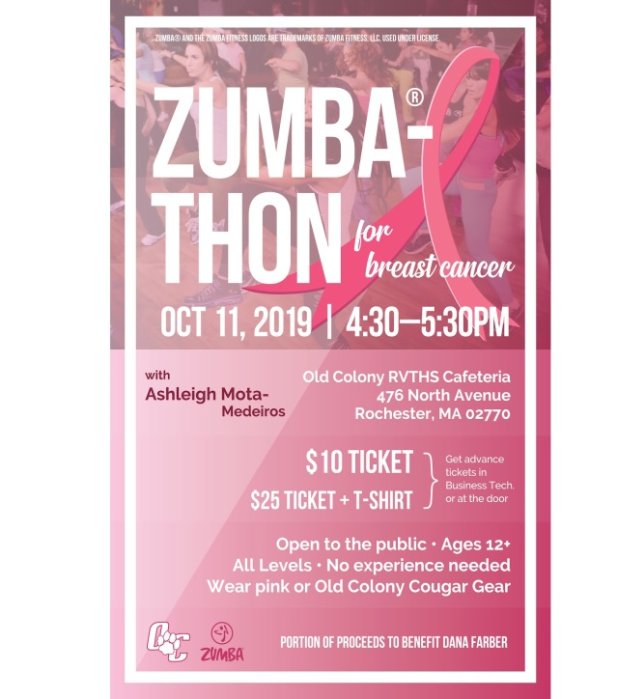
Come out and support Breast Cancer Awareness month by joining Mrs. Mota-Medeiros during her Zumbathon here at OC on October 11th from 4:30-5:30 pm. $10 donation, please where pink or OC Gear. A portion of the proceeds will benefit Dana Farber.

Seniors interested in becoming a shop representative, please see Mrs. Hoyle in Cosmetology. Seniors please check your email on Friday for their senior superlatives.

Any senior who is planning to apply to BCC is being asked to stop by the Guidance Office and sign the BCC list.

There will be a pre-season sign-up for all winter athletes on Oct. 10th at 1:30pm in the Gym. All athletes are required to attend.

Black and White Gala Ball is the then for this year’s Homecoming Dance. Tickets will be on sale on Thursday, Oct. 10th during all lunch shifts. Price per ticket is $12 each.

Spirit Week starts next week on Tuesday! Be sure to check the flyers around school for the themes each day!

Both Senior and Junior Classes are doing Yankee Candle fundraisers.

OCT. 11TH IS CANCELLED FOR SENIOR SUPERLATIVE WINNERS, SCHOOL CLUBS, CLASS OFFICERS AND SENIOR GROUP PHOTO DUE TO THE WEATHER. RESCHEDULED DATE WILL BE ANNOUNCED.

PLEASE DISMISS THE FRESHMAN VOLLEYBALL TEAM AT 2:00 PM FOR AN AWAY GAME.

ALL GOLF IS CANCELLED FOR THE REMAINDER OF THE WEEK. THERE WILL BE A TRI-MATCH ON TUESDAY AT HOME AND THE 8 MATCH PLAYERS WILL BE DISMISSED 1:50 PM.

