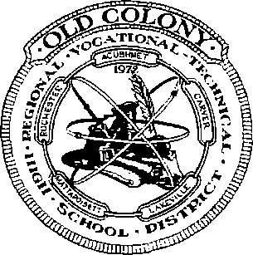

REGIONAL VOCATIONAL TECHNICAL HIGH SCHOOL DISTRICT  
476 NORTH Avenue, Rochester, Massachusetts 02770-1899

Telephone: 508-763-8011 • Fax: 508-763ᅳ9821

OLD COLONY



Karen J. Guenette Principal

Frank K. Coté  
Superintendent-Director

Jackie Machamer  
Assistant Principal/CVTE Coordinator

Krystla Fay

Special Services Coordinator

Sarah Griffith

Business Manager

FREETOWN/ASSONET  
BUS TRANSPORTATION

Bus transportation will be provided by First Group Services in Freetown for your child to Apponequet High School. There will be **2** buses at Apponequet High School waiting to transport your child to old Colony in the morning. First Group buses **(OC-l** and OC**-2)** will provide transportation home from Old Colony.

When Old Colony has school and the Freetown school system does not have school or when the Freetown school system announces a delay to the start of school due to inclement weather, buses will still run. The Freetown buses may be at the stops earlier due to fewer stops being made to pick up students. If a student is not in attendance at old Colony on these days, he/she will be charged an unexcused absence.

If a student has to stay after school for any reason (extra help, make­up work or a detention) it is the parent’s responsibility to provide transportation home. Freetown does not provide any late buses.

Because of insurance issues, Freetown/Assonet students are not allowed to ride any old Colony Reliable buses and Reliable bus students from Acushnet, Carver, Lakeville, Rochester or Mattapoisett are not allowed to ride First Group buses.

If you have any questions regarding transportation, please contact Old Colony’s main office at 508-763-8011 or First Group at 508-763-9260.

Kenny Rezendes

First Group Services

508-763-9260

ACUSHNET，CARVER, LAKEVILLE, MATTAPOISETT, ROCHESTER